Energy and Water Audit Report Template

Prepared For:

U.S. Mission Canada  
U.S. Department of State

**UNCLASSIFIED**

Prepared By:

Contractor Company Name

Contractor Address

Date:

Report Phase: (Final/Draft)

This page is intentionally blank.

Team Members

**NOTICE**

This report was prepared as an account of work sponsored by an agency of the United States government. Neither the United States government nor any agency thereof, nor any of their employees, makes any warranty, express or implied, or assumes any legal liability or responsibility for the accuracy, completeness, or usefulness of any information, apparatus, product, or process disclosed, or represents that its use would not infringe privately owned rights. Reference herein to any specific commercial product, process, or service by trade name, trademark, manufacturer, or otherwise does not necessarily constitute or imply its endorsement, recommendation, or favoring by the United States government or any agency thereof. The views and opinions of authors expressed herein do not necessarily state or reflect those of the United States government or any agency thereof.

Provide the contact information for each of the key personnel involved in this project. Include project managers, facility managers, and site assessment team members.

Department of State: Bureau of Overseas Buildings Operations

Mr. Walter O’Banion

Facility Manager Canada

613-688-5247

o’banionwr@state.gov

Department of State: Foreign Service at Post

Mr. Mark Atkisson

Contracting Officer

514-908-3737

atkissonmm@state.gov

Contractor

Name

Title/Role

Phone

E-mail

Table of Contents

Executive Summary 1

Project Context Review 6

Climate Assessment 6

Environmental Issues Assessment 8

Sustainability History and Vision 8

Building and Site Information 8

Utility Use Analysis 12

Utility Benchmarking 13

Energy Use Analysis 14

ASHRAE Level II Audit: 16

Energy Conservation Measures 18

Water Use Analysis 23

ASHRAE Level II Audit: 25

Water Conservation Measures 25

Renewable Energy Use and Recommendations 28

Appendix A: Detailed Climate Data 1

Appendix B: TREES Report Card 3

Appendix C: General Building Data from Output Tool Set 4

Appendix D: Photovoltaic Feasibility Guidance 6

Appendix E: Wind Feasibility Guidance 8

Appendix F: Summary of Recommendations 11

Appendix G: Translated Utility Bill 12

Appendix H: Glossary of Acronyms 14

How To Use This Template

Follow the guidance provided for the appropriate deliverable as indicated by the subheadings. Replace text and tables included in this template with project-specific information. Tasks covered within this template are:

* Meter Assessment
* Utility Data Gathering
* American Society for Heating, Refrigeration and Air Conditioning (ASHRAE) Level I Audit for energy and water
* ASHRAE Level II Audit for energy and water

Each project will be provided with an Exhibit A: Project Description to accompany the Statement of Work (SOW), completed by Post, which indicates which of the above tasks are included within the contractor’s scope of work.

Within the report, ensure that the following recommendations and measures are identified. To aid in categorization, a description of each reocmmendation/measure has been provided below.

* **Operations and Maintenance Recommendations:** Items that can be completed with little or no cost implications. These can be considered best management practices that, if adopted, would improve the facility’s performance.
* **Field Observed Deficiencies:** Items that should be corrected as soon as possible. These are items related to safety, operational requirements, or Department standard operating procedures.
* **Meter Assessment Recommendations:** Items that would improve the usefulness of the extensive metering network installed at the Post and bring the Post into full compliance with OBO’s Facility Meter Application Guideline.
* **Energy Conservation Measures**: Recommended projects that should be implemented to improve the energy efficiency of the Post. Recommended low cost/no cost measures should be implemented by the post as an expense item. Medium and high cost items should be entered into the Department’s project management platform for approval and funding.
* **Water Conservation Measures:** Recommended projects that should be implemented to improve the water efficiency of the Post. Recommended low cost/no cost measures should be implemented by the post as an expense item. Medium and high cost items should be entered into the Department’s project management platform for approval and funding.
* **Renewable Energy Measures**: Recommended projects that should be implemented that generate renewable energy at the post. Solar PV and wind generation may be evaluated using the Renewable Energy Tool, provided within Exhibit C: Energy and Water Audit Report Tool Set.

Throughout this template, guidance is indicated as specific to **[All Projects]**. Where [**All Projects]** is indicated, the contractor shall complete the section as directed, for all tasks selected in Exhibit A. Where another instruction is indicated in the format **[instruction]**, edit accordingly.

**Report length:** In general, the main body of the report should be concise so that Post can clearly identify key findings, recommendations, and desired or required actions. Additional or detailed information should be included in the appropriate Appendix.

**Header/Footer:** The report title shall be included on each page in addition to identifying the Department (OBO), date, and page number in a typical header/footer.

**Section headings and subheadings:** All reports shall maintain the section headings and subheadings as listed below.

* Executive Summary
* Project Context Review
  + Climate Assessment
  + Environmental Issues Assessment
  + Sustainability History and Vision
  + Building and Site Information
* Meter Assessment
* Water and Energy Analysis
  + Utility Analysis
  + Utility Benchmarking
  + Energy and Water Conservation Measures

Where there is no information for a section, indicate ‘No information is available at this time’ with a brief explanation. If the section relates to a task (e.g. ASHRAE Level II Audit) that is not indicated in Exhibit A, indicate ‘Section not required per the Scope of Work’ and maintain the section numbering.

**Content:** Provide information under the headings and subheadings listed in the template for each deliverable, where applicable.

* Follow the guidelines that identify the information to be presented within each section.
* Note that, whether or not Post self-performs Utility Data Gathering or Meter Assessment, the contractor is responsible for including that information in this report.
* Guidelines also apply to ASHRAE Level II Audits when they are included in the SOW.
* Each facility identified in the SOW Exhibit A: Project Description shall be addressed individually in the report, as necessary, within the submission for Post.
* Retain any information that does not change from one deliverable to the next.

**Examples:** The examples shown are required elements of the report. Additional graphics or text may be appropriate to include in the main report; however, in general, supplemental analysis or detail should be included in the appendices.

**Appendices:** Auditors may determine the bulk of the content of the Appendices; however, ensure that the basic information indicated in each section is included, and that the Appendix order is maintained. Appendices may include meeting minutes, data tables, supporting documents, photographs not otherwise included, and other documentation as required. Detailed modeling results must be provided in the Appendices when requested by the Department via the SOW.

**Tool Set:** This Energy and Water Audit Report Template shall be accompanied by a completed version of Exhibit C: Energy and Water Audit Report Tool Set (‘Tool Set’), which contains format and desired content for tables as indicated, in addition to a conservation measure evaluation table. Auditors may perform analysis in any qualified tool, but must include the results in the specified Microsoft Excel file. Auditors must retain the structure and reportable elements in each table of the Tool. A copy of the detailed table as an editable excel file must be included with each submittal.

NOTE THAT TABLES INCLUDED IN THIS TEMPLATE CONTAIN SAMPLE DATA ONLY

* If printing this template, please make sure the printer is set to black and white.

# Executive Summary

Provide an executive summary that is a few pages in length based upon the following outline. The summary shall contain an overview of each section of the report including key findings, conclusions, and recommendations. Locate detailed analysis, narratives, and charts in later sections of the report or Appendices, as noted.

[All Projects]

* Indicate each assessment that is included in the report (for example, ‘Utility Data Gathering, a Meter Assessment, and an ASHRAE Level II Audit were conducted at the United States Embassy Nepal, Kathmandu.’)
* Provide an onsite timeline, similar to the example shown in Exhibit E: Project and On-site Schedules, which displays a schedule of assessment activities.
* In one or two paragraphs, include a site overview section that addresses primary issues in the host country and region, and the buildings assessed.
* Provide one to two paragraphs summarizing the significant findings of the audit and proposed next steps to implement recommendations.
  + Include an ‘Immediate Actions’ paragraph that highlights Field Observed Deficiencies or any imminent problems or observations such as life safety or health issues, or plumbing leaks, which may be out of the scope of the audit, but were observed by the contractor.
  + Identify Operations and Maintenance Recommendations related to building system issues and opportunities that need immediate attention and process or procedural changes that will result in improved operations.
  + Briefly summarize recommended Energy Conservation Measures (ECMs), Water Conservation Measures (WCMs), and Renewable Energy Measures (REMs) in the following format: “This audit identified:
    - No- and low-cost energy and water conservation measures that could result in xx% energy savings at a cost of $yy with a payback of zz years and xx% water savings at a cost of $yy with a payback of zz years.
    - Medium-cost measures that could result in xx% energy savings at a cost of $yy with a payback of zz years and xx% water savings at a cost of $yy with a payback of zz years.
    - High-cost measures that could result in xx% energy savings at a cost of $yy with a payback of zz years and xx% water savings at a cost of $yy with a payback of zz years.”
* Provide an energy usage overview, indicating total annual consumption and cost by utility type.
  + Use the utility performance table provided in the Tool Set. An example is provided below.



* + Provide a summary of recommendations table, organized by the assessment component, which synthesizes recommendations based on the findings of the assessment. Using the cost summary and ECM summary tables provided in the Tool Set, quantify energy, water, and cost savings of recommendations. Some examples have been provided below.

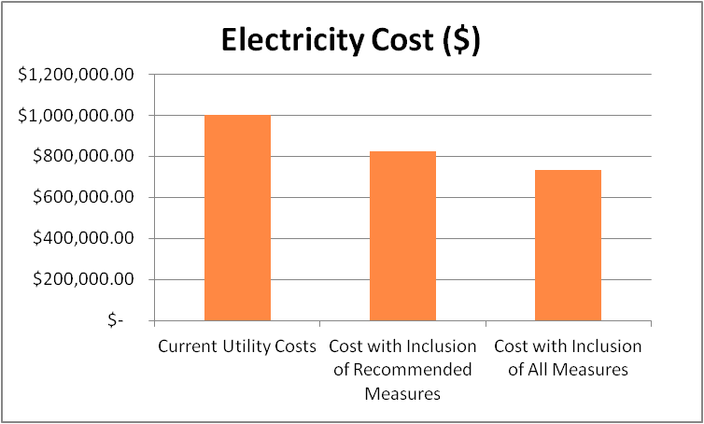

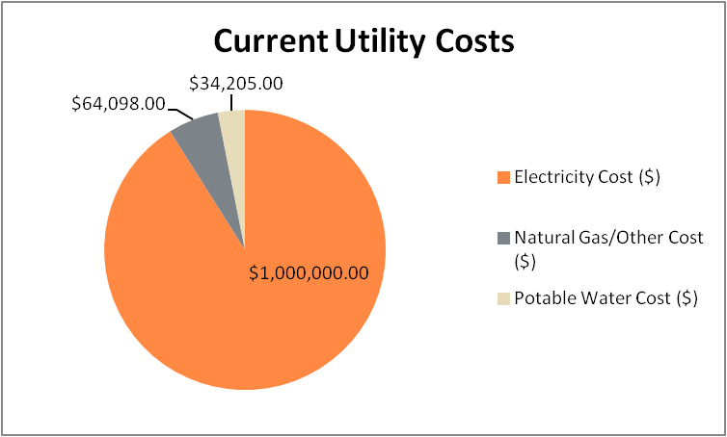

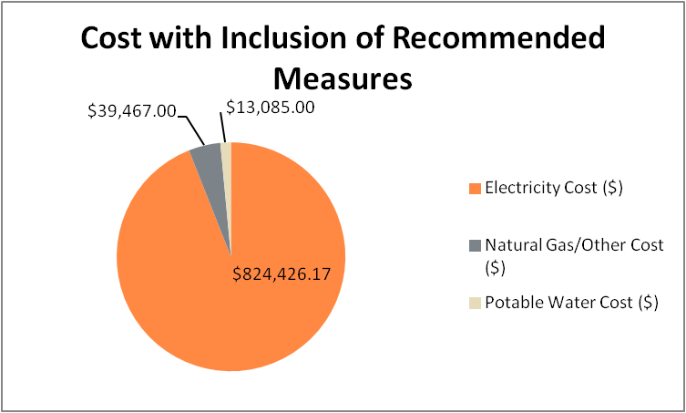



* + Include both text and icons which identify the magnitude of benefit; time to conceive, plan, and implement; and cost investment. Model the organization strategies of the *Guide to Green Embassies: Eco-Diplomacy in Operation.*
  + Do not include a comprehensive list of all conservation measures assessed in the Executive Summary. Detail should be provided in the following sections, in an Appendix, or as an attachment in the form of the Life Cycle Cost Analysis (LCCA) Tool (located within the Tool Set).

Strategy classifications as shown in the User Guidance section of the *Guide to Green Embassies: Eco-Diplomacy in Operation*.

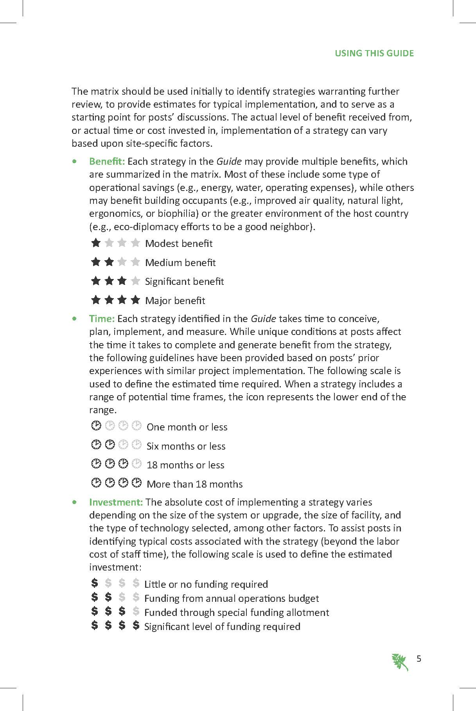

# Project Context Review

This background section length should be commensurate with the size and complexity of the building/Post. Unless indicated below, locate detailed analysis, narratives, and charts in Appendices.

## Climate Assessment

### [All Projects]

* Use the most current version of *Climate Consultant* to perform a climate analysis, to ensure consistency of graphic content and presentation in project reports. *Climate Consultant* is freeware that can be downloaded from: <http://www.energy-design-tools.aud.ucla.edu/>
  + From the *Climate Consultant* website 2013: “All our Energy Design Tools are fast, easy to use, highly graphic, and free. Each has a built in demonstration. Each has an automatic INSTALL routine or a READ.ME file explaining how to use it. You are welcome to publish the output and share copies provided that the Regents Copyright and Terms of Use remain unaltered.”
  + At a minimum, perform an analysis of the following information:
    - Latitude/Longitude
    - Elevation Above Sea Level (identify the elevation of the main building’s entrance)
    - Heating and cooling degree days (with resultant ASHRAE climate zone) as identified in the Tririga Real Estate Environmental Sustainability (TREES) Utility Management system Report Card (see example in Appendix B)
    - Seismic Zone
    - Annual temperature and annual temperature variance
    - Wind speed, direction, and duration
    - Solar angles, insolation, and radiation
    - Relative humidity and dry bulb
    - Annual and monthly rainfall including average duration and intensity
    - Psychrometric chart
    - Geography/topography/microclimate/soil conditions
  + Provide a maximum two page summary of the main climate analysis results. Include a few of the most relevant charts, including those represented by the examples shown here. More detailed climate data should be included in the Appendices.

Climate analysis example from U.S. Embassy Harare, Zimbabwe (provided by Paladino):

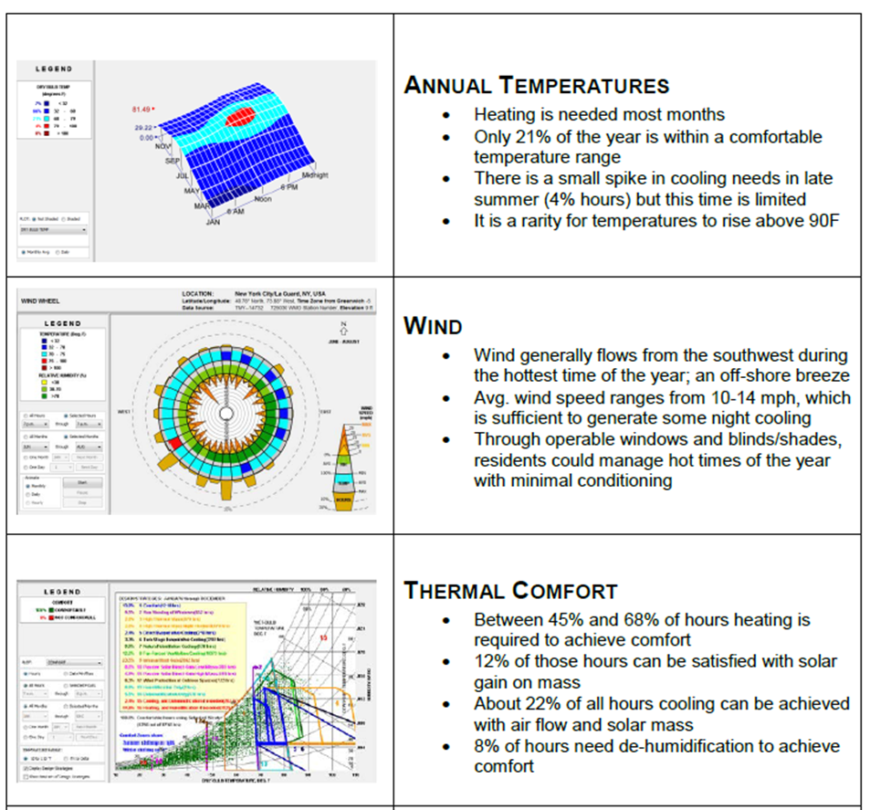

## Environmental Issues Assessment

### **[All Projects]**

* Identify the environmental risks for each primary office site. Include an Appendix describing the assumptions related to and definitions for each of the following environmental conditions, including references and sources:
  + Energy Security/Risk
  + Water Scarcity/Risk
  + Drought Risk
  + Desertification Risk
  + Aquifer Health Risk
  + Aquifer Accessibility Risk
  + Flood Risk (proximity to water bodies prone to flooding, storm surge, or sea level rise and consideration of 100-year flood plain if documented)

## Sustainability History and Vision

### [All Projects]

* State what Post hopes to accomplish with the assessment and which elements of sustainability are most important.
* Discuss any energy and sustainability audits and upgrades that have been performed for the property and the relative successes/challenges in maintaining performance of them.

## Building and Site Information

### [All Projects]

* For each building assessed, complete the appropriate tables in the Tool Set:
  + Characteristics - Building
  + Characteristics - Shell
  + Schedule - Building
  + Schedule - Space
* Include systems descriptions for:
  + Electrical service (including generators, fuel storage and renewable energy as applicable)
  + Heating, ventilating, air conditioning (HVAC) and refrigeration
  + Lighting and lighting controls
  + Controls and building automation system
  + Water supply and consumption (including wells, storage, supply piping, treatment, filtration, domestic hot water, irrigation, cooling/process water)
  + Waste water treatment (including packaged treatment plants, or constructed wetlands if applicable)
  + Fire suppression systems
  + Vertical and horizontal transportation systems (including elevators and conveyors)
* Include a section on field observed deficiencies (FOD).
* Identify any life safety deficiencies, operational requirements, or Department standard operating procedures.
* Include a section on operations and maintenance recommendations (OMR) which can be implemented at little to no cost and are considered best management practices.
* Include any documented findings from interviews or surveys with Post employees.
* Document any other detailed information and large or complex charts and graphical output in the Appendix.

[if included in scope of work, complete the following section]

### ASHRAE Level II Audit

* Review the mechanical and electrical system design, installed condition, maintenance practices, and operating methods. Compare the operating parameters to the intended design levels and indicate any deviations.

Meter Assessment

[All Projects]

Provide results from the meter assessment using the tables in the Tool Set. Indicate recommendations for compliance with OBO Facility Meter Application Guideline.

Whether the assessment was performed by post personnel or by the contractor, it is the contractor’s responsibility to analyze, summarize, and include the information in this section.

If the Meter Assessment is self-performed by Post, indicate that the information presented in the report is based upon data provided by Post.

Overview

Briefly summarize the utilities serving Post that are currently metered, and recommendations for meeting the requirements within the OBO Facility Meter Application Guideline.

* Provide building utility metering description, including a detailed account of the building automation system and sub-metering (where applicable).
* Complete the meter tables, for electricity, water, gas, other energy, or generator as applicable within the Tool Set, per the example below.

|  |  |  |
| --- | --- | --- |
| Meter #1 |  |  |
| **Metered Utility** | Electricity | | |
| **Location** | Chancery Rm B38 | | |
| **Standalone or connected to BAS?** | Standalone | | |
| **Building/area/ equipment served** | Chancery and Annex | | |
| **Circuit** | Utility Bus | | |
| **Make & Model** | GE EPM6000 | | |
| **Serial Number** | n/a | | |
| **Voltage and Amperage** | 480V | | |
| **Other characteristics** | Not monitored | | |

Results

Identify where meters need to be installed and/or upgraded to meet Facility Meter Application Guideline. Metering Assessment Recommendations (MARs) should be categorized by utilty and should include type, size, make and model, and location of the meters. MARs should also identify if repairs are needed and if alternative trending data should be collected from the new and existing meters. Provide a meter layout diagram similar to the example shown below.

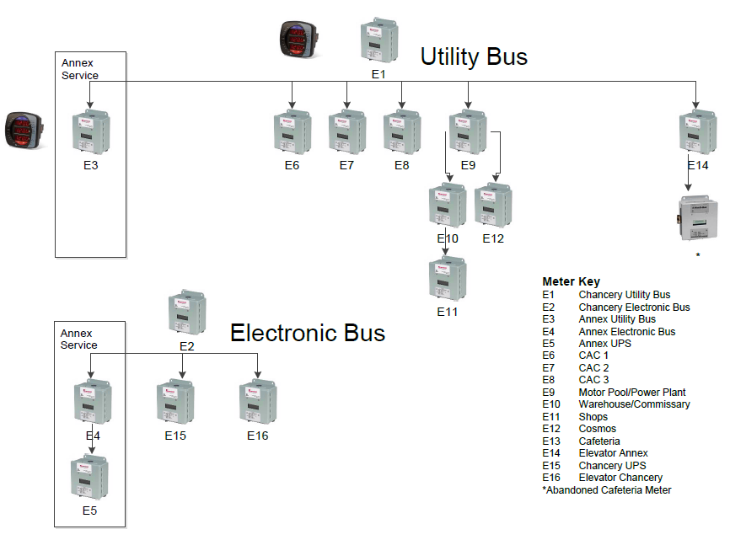

# Utility Use Analysis

[All Projects]

Perform an on-site review of the building systems and operation and a detailed analysis of energy and water use and opportunities for conservation. As part of the utility data gathering task, obtain copies of utility bills to provide a better understanding of rates and charges including demand charges, tariffs, taxes, ratchet rate, time-of-day, and power factor penalties.

Include completed tables from the Tool Set. Whether utility data gathering activities are performed by Post or by contractor, it is the contractor’s responsibility to analyze, synthesize, and summarize the information in this report.

If Utility Data Gathering is self-performed by Post, indicate that the information presented in the report is based upon data provided by Post.

* Utility Data Gathering Review and provide an analysis of the following:
  + At least 12 months of building and site utility consumption and cost data, preferably for the most recent 12 months preceding the assessment. Review up to 36 months of data.
  + Lump sum utility data for the facilities identified in Statement of Work (SOW), Exhibit A: Project Description from 2007 to present, as available
  + TREES Utility Management System Report Card(s), if available.
* Provide the following information:
  + Completed Metered Data tables for each utility within the Utility Analysis Tool, provided within Tool Set.
  + For buildings where utility data is available in TREES, the TREES Utility Management System Report Card(s) in Appendix B.
  + A sample of each utility bill with noted translations, as shown in Appendix G.
* Include a summary of the utility rate structure for each primary utility type. Include all relevant components, such as demand and use charges, power factor charts, taxes, peak rates, and other relevant attributes.
* Based on the analysis of the utility data, provide a brief summary of the facilities' relative performance, potential opportunities for improvement and cost savings, and recommended further investigation.

## Utility Benchmarking

### [All Projects]

* Perform benchmarking of the building to compare it to similar building types. Indicate the energy use index (EUI) of the building and compare it to the EUI of similar buildings. For all posts note the fraction of current costs that would be saved if the energy index were brought to the target or benchmark level.
  + For posts that utilize the TREES Utility Management System, use the benchmarking performed in the TREES Report Card. Include the Ranking of Buildings graph, as shown in the example below.

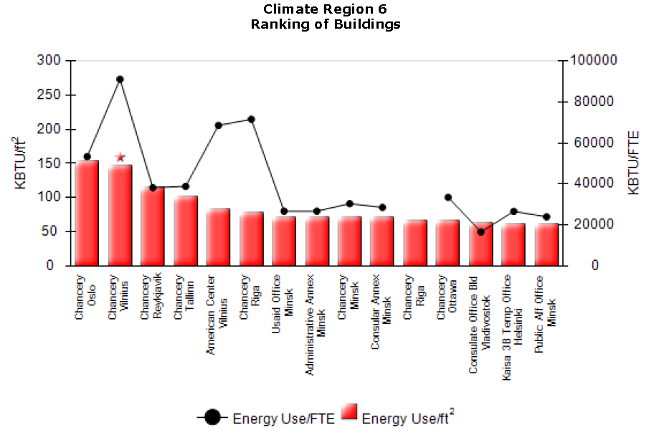

* + For posts that do not have utility data in the TREES Utility Management System, ensure that the benchmarking includes the source, size and date of the sample used in comparison. Provide a building benchmarking analysis table.

Benchmarking example from U.S. Embassy Kathmandu, Nepal (provided by Paladino):

|  |  |  |  |  |  |  |
| --- | --- | --- | --- | --- | --- | --- |
| Table: Comparison with Similar Buildings | | | | | | |
| Building | Year Built | Occupant Density  Sq. ft./FTE | Weekly Op Hours | EUI (Site) kBTU/sq. ft./yr | Cost $/sq. ft./yr. | Energy Star Rating |
| A | 1991 | 654 | 74 | 62 | $2.37 | 82 |
| B | 1999 | 459 | 72 | 66 | $2.48 | 84 |
| C | 1991 | 509 | 56 | 66 | $3.29 | 79 |
| Chancery | 2007 | 287 | 61 | 71 | $2.72 | 82 |

* Complete an ENERGY STAR evaluation of each building identified in the SOW’s Exhibit A: Project Description to establish a baseline. Provide the utility information in format that can be entered into the ENERGY STAR Portfolio Manager database.

## Energy Use Analysis

### [All Projects]

* Include a completed energy cost and consumption by fuel type table from the Tool Set for the latest year and the preceding two years (if available). An example is provided below.

|  |  |  |  |
| --- | --- | --- | --- |
| **Year** | **Annual Energy Consumption (kWh)** | **Units** | **Annual Cost ($)** |
|
| 2013 | 1,459,354 | kWh | 165,350 |
| 2012 | 1,459,354 | kWh | 165,350 |
| 2011 | 1,459,354 | kWh | 165,350 |

* Provide a monthly energy usage graph for each primary fuel type, such as the example below.
* Include a completed energy use breakdown by major end uses table from the Tool Set. An example is provided below.
* Quantify potential savings from changing to a different utility price structure
* Discuss irregularities found in the monthly energy use patterns, with suggestions about their possible causes.

### [If included in scope of work, complete the following section]

## ASHRAE Level II Audit:

* Include a breakdown of the total annual energy use into end-use components as illustrated in the 2011 ASHRAE Handbook-Application, Chapter 34, Figure 4, or as shown in the section “Energy Analysis Summary and Recommendations”. Provide a graph from the Tool Set, as shown in the example below.

* Create an energy profile curve for each building by combining the energy use with historical weather data. Organizing the months from coldest to warmest using heating and cooling degree days uncovers what parts of the load are associated with heating, cooling and base conditions.

Energy Load Profile Curve example from U.S. Embassy Sofia, Bulgaria (provided by Paladino):

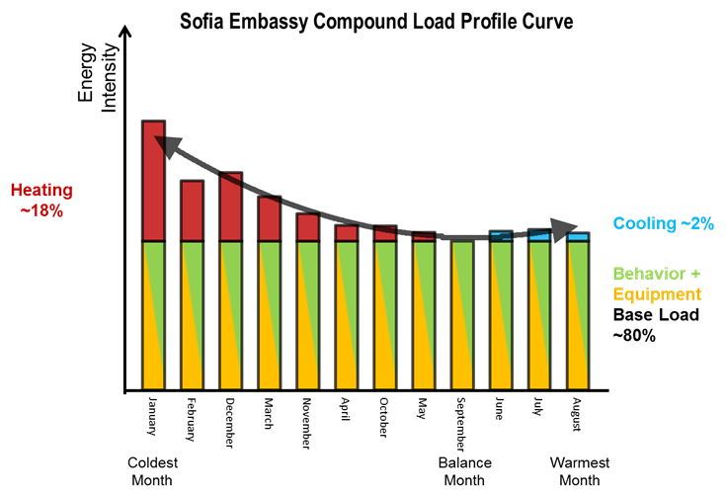

## Energy Conservation Measures

### [All Projects]

* Provide a summary of the process used to identify the ECMs.
* Evaluate ECMs in the following categories:
  + Passive Design
  + Lighting
  + HVAC
  + Renewable Energy (RE)
  + Water
  + Schedule Changes
  + Plug Loads
  + Process Loads
  + Wastewater
* Provide a budget analysis of each potential ECM and include these in the LCCA table.
* The auditor must assess, at minimum, the following measures:
  + Lighting (fixture/lamp/controls) upgrade
  + Adjustment of HVAC Building Automation System (BAS) set points/sensors
  + HVAC system balancing
  + Adjustment of temperature set points
  + Motors with variable frequency drive (VFD) Controllers
  + Pool cover installation
  + Reduced use of desktop printers/copiers
* Summarize ECMs, organized from no-/low- to medium- and high-cost items, along with the predicted savings for and cost to implement these improvements. An example has been provided on the following page.
  + The measures shall be identified and described for both technical and non-technical readers.
  + Provide rationale for decisions on which measures are recommended, as well as justification based on the following: implementation cost, consumption savings, operations and maintenance savings, and general industry best practice.
  + Include a list of post-deferred maintenance items.
    - The list shall include equipment that is obsolete or that has not been properly maintained due to deferred maintenance. Include the estimates for replacement and/or repair in the LCCA table.
  + Indicate any systems recommended for commissioning or measurement and verification.
    - The list shall include equipment that should remain in each facility and requires re-commissioning or retro-commissioning. The recommendations shall also identify the level of effort required to complete the commissioning recommended.
    - Briefly discuss the value of performing measurement and verification in association with commissioning activities.
  + Include recommendations for system replacement options in favor of newer technologies (geothermal, mag-lev chillers, etc.).
* Provide a complete report on the findings including recommendations required to rectify any deficiencies and to meet the requirements of Executive Order 13423, Energy Policy Act (EPAct) 2005 and Energy Independence and Security Act (EISA) 2007.

[if included in scope of work, complete the following section]

ASHRAE Level II Audit:

* For a Level II Audit, provide detailed ECM recommendations for all practical measures including proposed implementation plans.
  + Review this list with the facilities team prior to inclusion in the report and ensure that they are listed in the anticipated order of implementation.
* Include the following details with each suggested measure:
  + Discussion of the existing situation and why it is using excess energy
  + An outline of the recommended action
  + Budget analysis detailed under the ASHRAE Level I requirements
  + Impacts on:
    - Occupant health, comfort, and safety
    - Operating and/or maintenance procedures
    - Occupant service capabilities
  + Any new skills required in operating staff, recommended training or hiring
  + Any recommended measurement and verification methods that will be required to determine actual effectiveness of the measure

Energy Conservation Measure example from U.S. Embassy Tokyo, Japan (provided by Green Building Services):

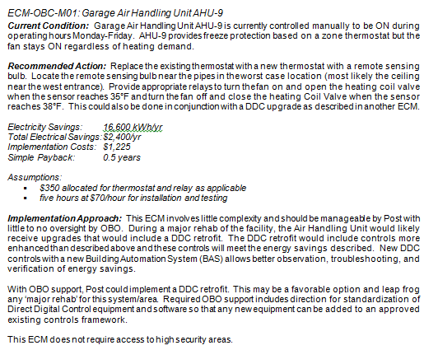

* Summarize the potential savings for each package of measures according to the LCCA table analysis, as shown in the example below created from the ECM summary table in the Tool Set.

|  |  |  |  |  |
| --- | --- | --- | --- | --- |
|  | | **Low-and no-cost** | **Medium-cost** | **High-cost** |
| **FINANCIAL (ENERGY ONLY)** | Net Annual Savings (US$) | $80,407 | $111,427 | $204,628 |
| First Costs (US$) | $843,861 | $705,156 | $1,314,441 |
| Simple Payback (yrs) | 10 | 6 | 6 |
| Financial Payback (yrs) | 9 | 6 | 6 |
| Net Present Value (NPV) (US$) | $14,248,631 | $20,352,402 | $37,016,653 |
| **ENERGY** | Total (MWh/yr) | 546,169 | 341,829 | 969,829 |

* Discuss any measures considered but felt to be impractical and the reasons for rejecting each, along with any feasible capital-intensive measures that may require an ASHRAE Level III analysis.
* Include detailed analysis such as calculations and charts for individual conservation measures in an Appendix.

## Water Use Analysis

### [All Projects]

* Include a completed water cost table and/or graph from the Tool Set for the latest year and the preceding two years (if available). Examples are shown below.

|  |  |  |  |
| --- | --- | --- | --- |
| **Year** | **Annual Consumption** | **Units** | **Annual Cost ($)** |
|
| 2013 | 345,029,492 | kl | 34,205 |
| 2012 | 345,029,492 | kl | 34,205 |
| 2011 | 345,029,492 | kl | 34,205 |
|  |  |  |  |

* Provide a monthly water usage graph, such as the example below.
* Include a completed water use by major end uses table for the Tool Set. Provide a graph from the Tool Set, as shown in the example below.

* Quantify potential savings from changing to a different utility price structure.
* Discuss irregularities found in the monthly water use patterns, with suggestions about their possible causes.

[if included in scope of work, complete the following section]

## ASHRAE Level II Audit:

* Include a breakdown of the total annual water use into end-use components. An example from the Tool Set has been shown below.

## Water Conservation Measures

### [All Projects]

* Evaluate WCMs, provide a budget analysis of each potential WCM, and include these in the LCCA table.
  + The auditor must assess, at minimum, the installation of low- and no-flow water fixtures. The assessment must include potential water supply, treatment and disposal cost savings and maintenance cost savings.
* Summarize WCMs, organized from no- and low- to medium- and high-cost items, along with the predicted savings for and cost to implement these improvements. An example, generated from the WCM summary table of the Tool Set, is shown below.

|  |  |  |  |  |
| --- | --- | --- | --- | --- |
|  |  | **Low-and no-cost** | **Medium-cost** | **High-cost** |
| **FINANCIAL (WATER ONLY)** | **Net Annual Savings (US$)** | $21,979 | $22,014 | $22,014 |
| **First Costs (US$)** | $157,978 | $157,978 | $157,978 |
| **Simple Payback (yrs)** | 7 | 7 | 7 |
| **Financial Payback (yrs)** | 7 | 7 | 7 |
| **Net Present Value (NPV) (US$)** | $158,252,738 | $158,253,175 | $158,253,175 |
| **WATER** | **Total Savings (m3/yr)** | 29,353 | 29,404 | 29,404 |

* + The measures shall be identified and described for both technical and non-technical readers.
  + Provide rationale for decisions on which measures are recommended, as well as justification based on the following: implementation cost, consumption savings, operations and maintenance savings, and general industry best practice.
  + Include a list of post-deferred maintenance items.
    - The list shall include equipment that is obsolete or that has not been properly maintained due to deferred maintenance. Include the estimates for replacement and/or repair in the LCCA table.
  + Indicate any systems recommended for commissioning.
    - The list shall include equipment that should remain in each facility and requires re-commissioning or retro-commissioning. The recommendations shall also identify the level of effort required to complete the commissioning recommended.
  + Include recommendations for system replacement options for new technologies.
* Provide a complete report on the findings including recommendations required to rectify any deficiencies and to meet the requirements of E.O. 13423, EPAct 2005 and EISA 2007.

[if included in scope of work, complete the following section]

### ASHRAE Level II Audit:

* For a Level II Audit, provide detailed WCM recommendations for all practical measures including proposed implementation plans.
  + Review this list with the facilities team prior to inclusion in the report and ensure that they are listed in the anticipated order of implementation.
* Include the following details with each suggested measure:
  + Discussion of the existing situation and why it is using excess energy
  + An outline of the recommended action
  + Budget analysis detailed under the ASHRAE Level I requirements
  + Impacts on:
    - Occupant health, comfort, and safety
    - Operating and/or maintenance procedures
    - Occupant service capabilities
  + Any new skills required in operating staff, recommended training or hiring
  + Any recommended measurement and verification methods that will be required to determine actual effectiveness of the measure

Water Conservation Measure example from U.S. Embassy Kathmandu, Nepal (provided by Paladino):

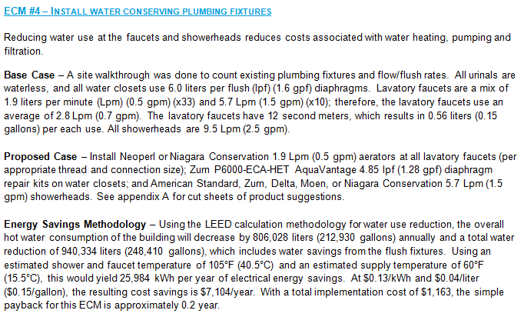

* Discuss any measures considered but felt to be impractical and the reasons for rejecting each, along with any feasible capital-intensive measures that may require an ASHRAE Level III analysis.
* Include detailed analysis such as calculations and charts for individual conservation measures in an Appendix.

## Renewable Energy Use and Recommendations

### [All Projects]

* Make recommendations for RE, such as photovoltaics, solar hot water heating, or wind power. The evaluation must, at a minimum, include the following:
  + Install Solar Hot Water
  + Photovoltaic Power Installation, see Appendix D for guidance
  + Wind Power Installation, see Appendix E for guidance
* Optional: Refer to the feasibility calculators included in the Tool Set.
* Evaluate REMs, provide a budget analysis of each, and include these in the LCCA table.
  + As part of the analysis, investigate the feasibility of selling excess power back to the utility.
* Summarize REMs, organized from no- and low- to medium- and high-cost items, along with the predicted savings for and cost to implement these improvements. An example, generated from the REM summary table in the Tool Set, is shown below.

|  |  |  |  |  |
| --- | --- | --- | --- | --- |
|  |  | **Low-and no-cost** | **Medium-cost** | **High-cost** |
| **FINANCIAL (RENEWABLES ONLY)** | Net Annual Savings (US$) | $80,407 | $111,427 | $204,628 |
| First Costs (US$) | $843,861 | $705,156 | $1,314,441 |
| Simple Payback (yrs) | 10 | 6 | 6 |
| Financial Payback (yrs) | 9 | 6 | 6 |
| Net Present Value (NPV) (US$) | $844,866,088 | $706,548,838 | $1,316,998,850 |
| **RENEWABLE ENERGY** | Total Savings (MWh/yr) | 166 | 968 | 968 |

# Appendix A: Detailed Climate Data

In Appendix A, provide any additional charts not included in the main report. Include any relevant additional studies and detailed analysis in this section.

Example from U.S. Embassy Harare, Zimbabwe (provided by Paladino):

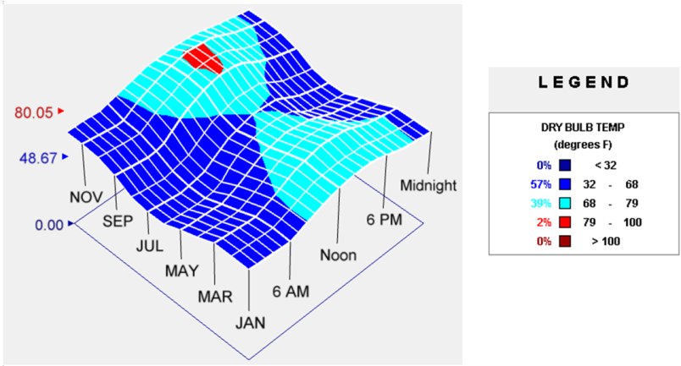

Annual Temperature range for Harare

* 38% of the year is within a comfortable temperature range. This time is primarily within the occupied hours (7 AM to 8 PM).
* During the winter months, some heating is needed, though it is anticipated that internal loads within the embassy would mean that a heating system is not required (see Abundance of Internal Loads section of this report).
* There is a small spike in cooling needs from September through November, but this time is limited and not excessive in temperature; it is a rarity for temperatures to rise above 32º C (90º F).

Solar angles example from U.S. Embassy Mbabane, Swaziland (provided by H&A):

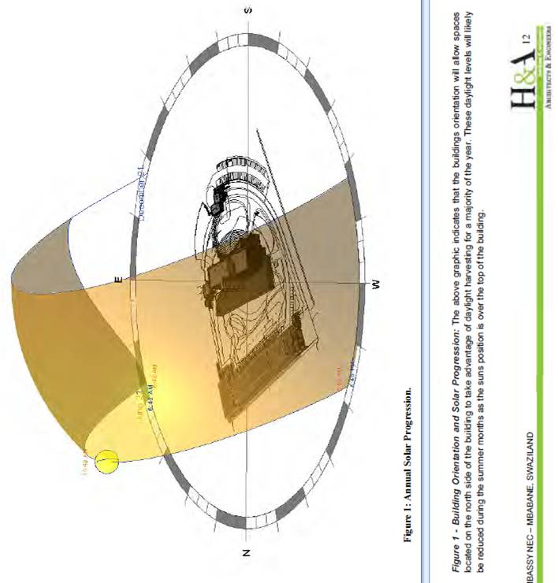

# Appendix B: TREES Report Card

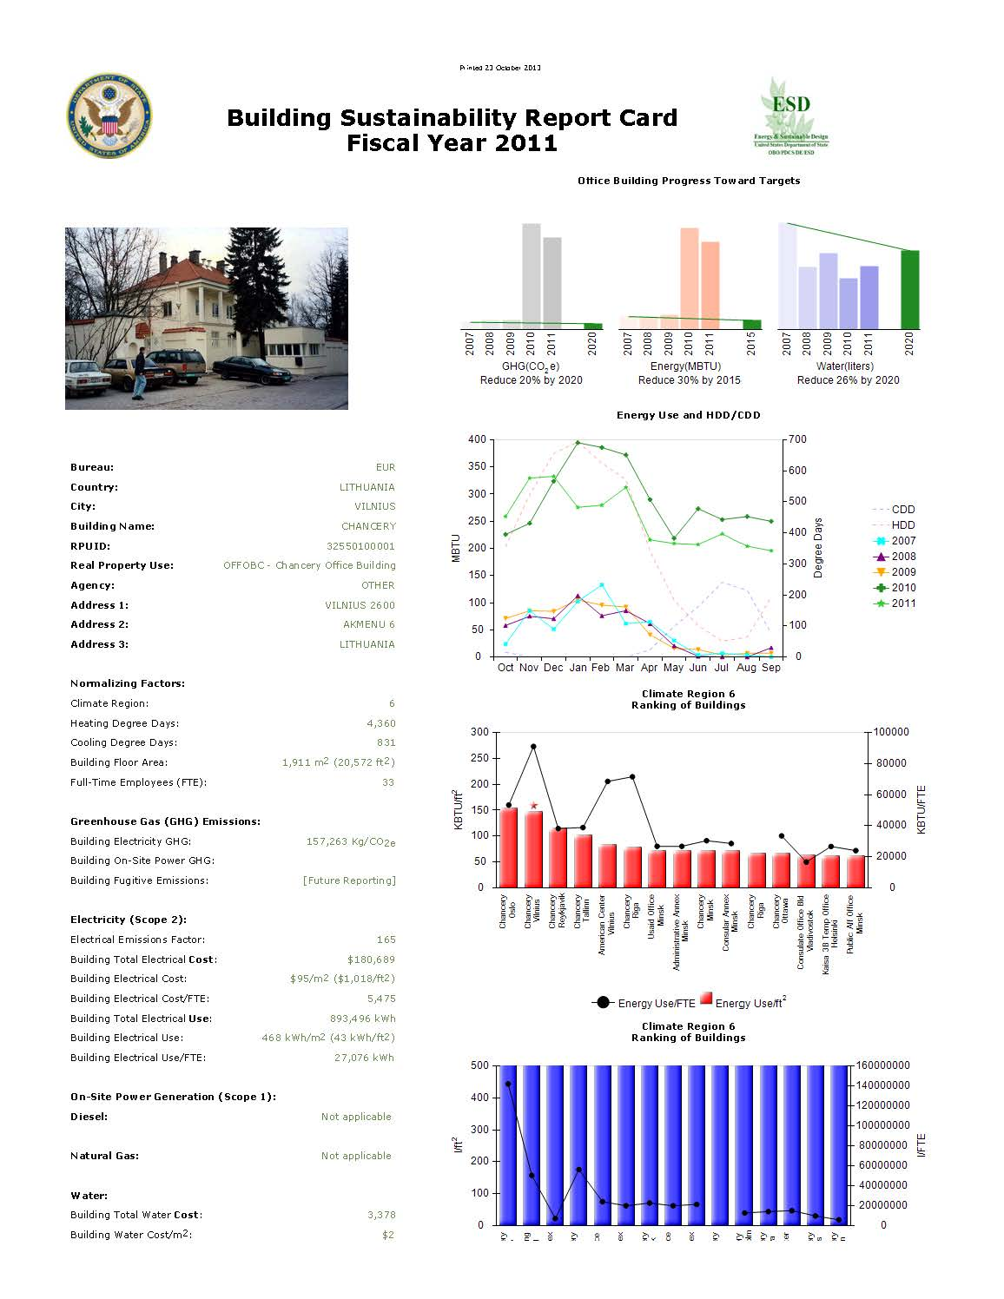

# Appendix C: General Building Data from Tool Set

|  |  |
| --- | --- |
| Building Name and Post |  |
| Address |  |
| Audit Date |  |
| Building Type (office, residential, etc.) |  |
| Building Use Summary |  |
| Year of Construction |  |
| Date of Last Major Renovation |  |
| Gross Floor Area (m2) |  |
| Conditioned Area (m2) |  |
| Number of Floors |  |
| Design Occupancy (FTE) |  |
| Typical Building Schedule Summary (business hours, continuous, seasonal, 24/7, etc.) |  |
| Interval Data Available (Y/N) |  |
| General Lighting Description |  |
| Plumbing Fixtures Description |  |
| Power Service and Distribution Description |  |
| Mechanical System Description |  |
| Controls and Building Automation Description |  |
| Water Supply |  |
| Wastewater Treatment |  |
| Fire Suppression Systems |  |
| Vertical and Horizontal Transportation Systems |  |
| Notes |  |

# Appendix D: Photovoltaic Feasibility Guidance

The Contractor shall provide a PV evaluation for each site. Refer to the Output Tool Set for an optional feasibility calculator provided by OBO. The evaluation shall include: online data gathering, risk and resources evaluation, and documentation of the assessment.

* Provide a few paragraphs discussing the viability of PV development on site. Describe relative benefits and drawbacks and the potential payback.
* Identify PV parameters collected on-site and data gathered on-line.
* Determine the amount of site and roof area required for a PV installation, and determine potential locations at Post.
  + Include a current aerial photograph (from Google Earth or equal) of the existing site and a dated site plan provided by OBO.
  + Briefly describe opportunities and constraints that may influence available site and roof areas.
  + Identify potential locations for PV considering possible fall radius on the site plan.
  + Identify total renewable generation capacity, and order-of-magnitude costs and utility savings of roof or site location options.
  + Provide a conceptual sketch of potential equipment locations on the site, similar to example shown below. If a solar assessment is performed along with a wind assessment, provide one sketch with the proposed potential locations of both PV and wind turbine(s).
* Provide a one line diagram that identifies the major components of the system.
* Provide a simple cost assessment and simple payback for the most likely system to be installed determined by Post.

PV Feasibility example from U.S. Embassy Abidjan, Ivory Coast (provided by OBO, reformatted by Paladino):

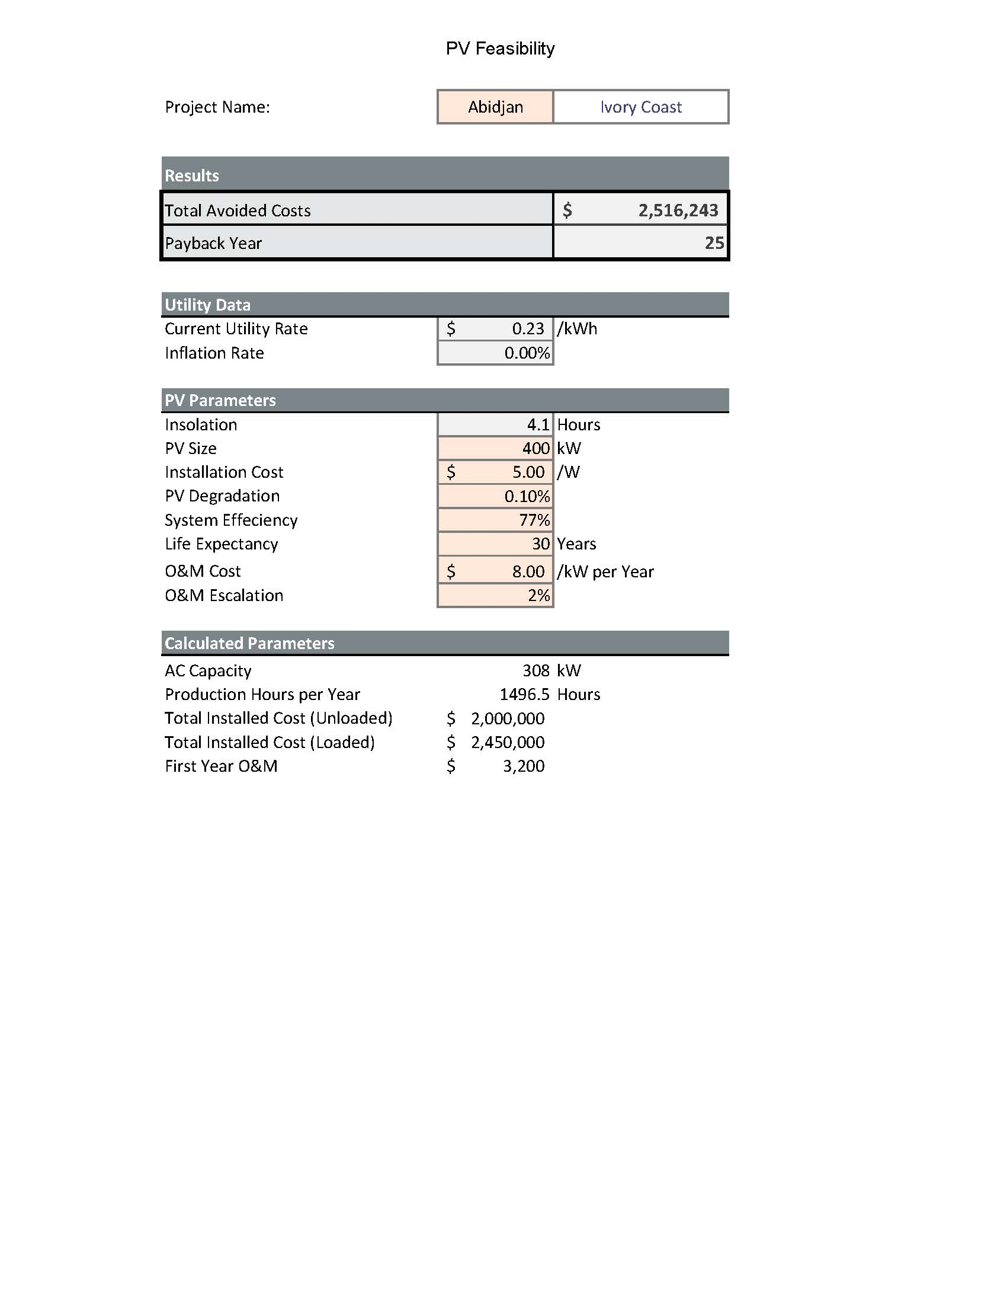

Potential PV Locations example from U.S. Embassy Lima, Peru (provided by Paladino):

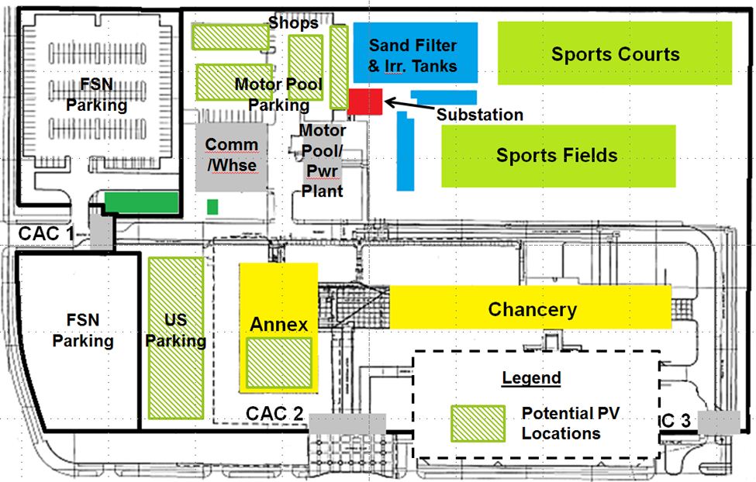

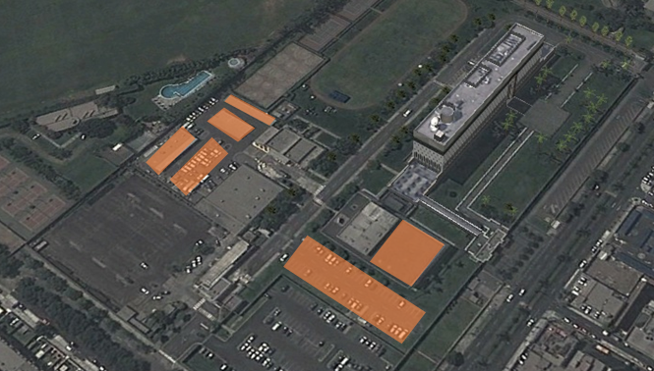

# Appendix E: Wind Feasibility Guidance

To evaluate the wind resources (max/average/min calculated at 30m from the ground), the Contractor shall purchase or subscribe to a service to offer historic wind data for each site. This service shall be equal to a 3Tier resource system. This resource will be available to the contractor for this task order as well as future wind resource evaluation task orders. The Contractor shall also document the hurricane or available event wind speed.

Refer to the Output Tool Set for an optional feasibility calculator provided by OBO.

* Provide a few paragraphs discussing the viability of a wind energy installation on-site, and an associated recommendation. Describe relative benefits and drawbacks and the potential payback.
* Identify the wind evaluation parameters.
* Determine the amount of site area required for a wind turbine, and determine potential locations at Post.
  + Include a current aerial photograph (from Google Earth or similar) of the existing site and a dated site plan provided by OBO.
  + Briefly describe opportunities and constraints that may influence available site and roof areas.
  + Identify potential locations for wind turbines considering possible fall radius on the site plan.
  + Identify total renewable generation capacity, and order-of-magnitude costs and utility savings of roof or site location options.
  + Provide a conceptual sketch of potential equipment locations on the site, similar to example shown below. If a solar assessment is performed along with a wind assessment, provide one sketch with the proposed potential locations of both PV and wind turbine(s).
* Provide a simple cost assessment and simple payback for the most likely system to be installed determined by Post.

Wind Feasibility example (provided by OBO, formatted by Paladino):

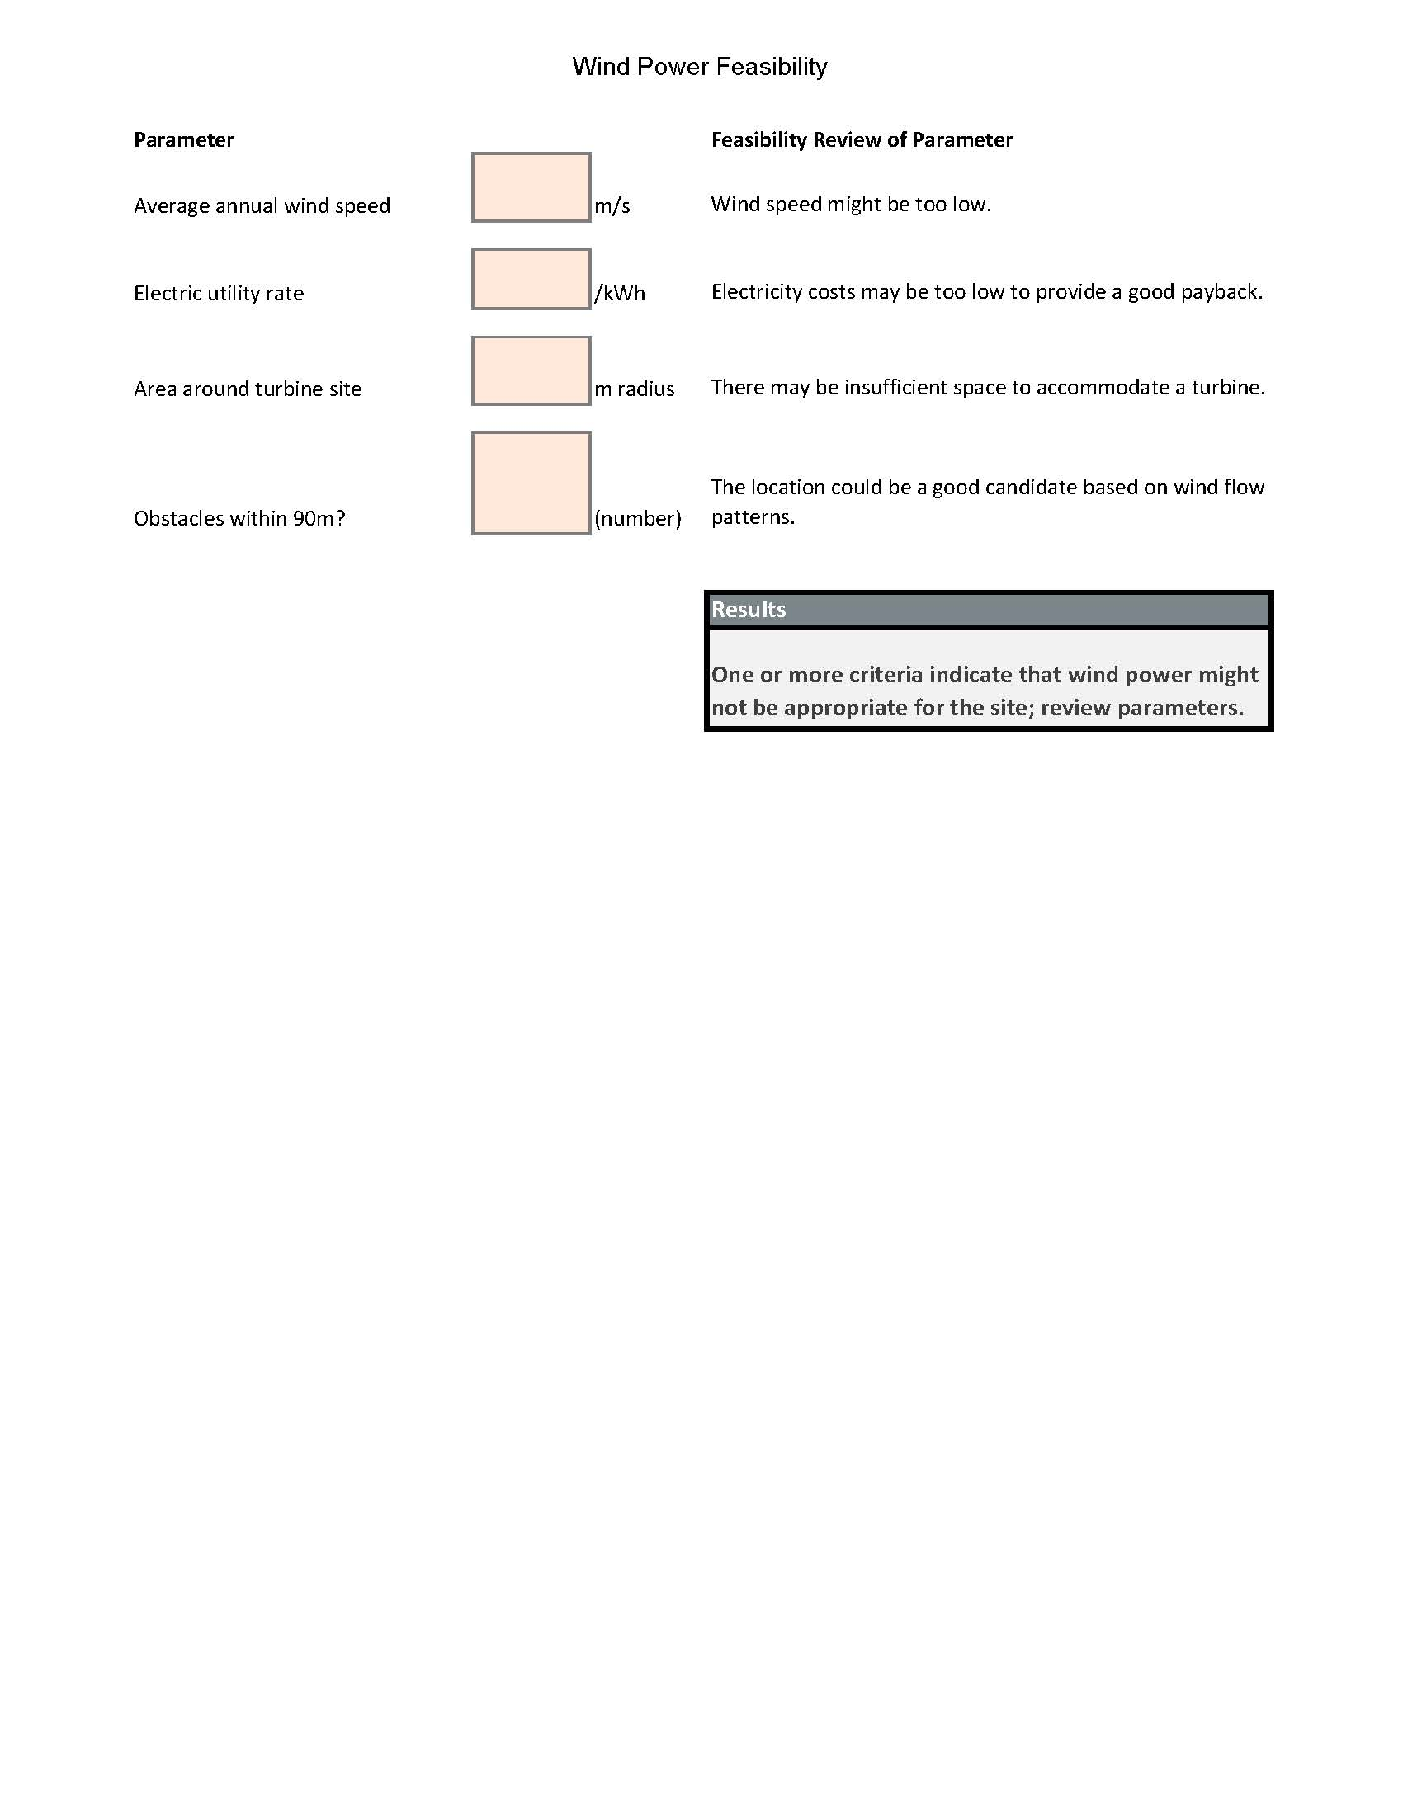

Potential Wind Turbine Location example from U.S. Embassy Maputo, Mozambique (provided by OBO):

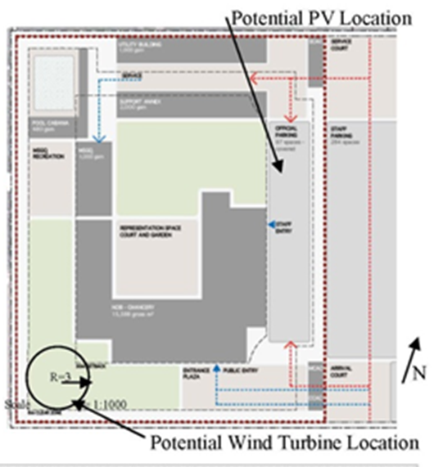

# Appendix F: Summary of Recommendations



# Appendix G: Translated Utility Bill

Electricity bill from U.S. Embassy in Lima (provided by Paladino):

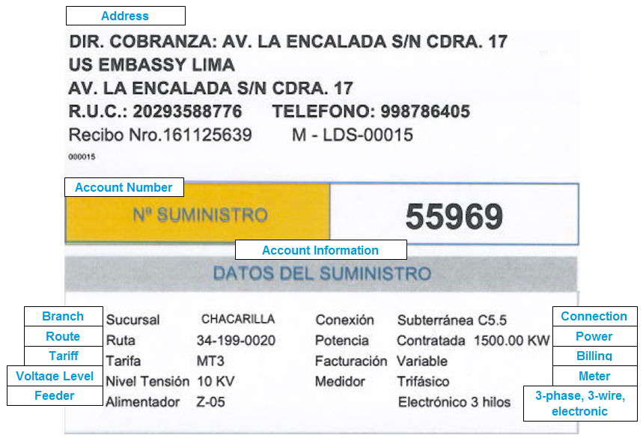

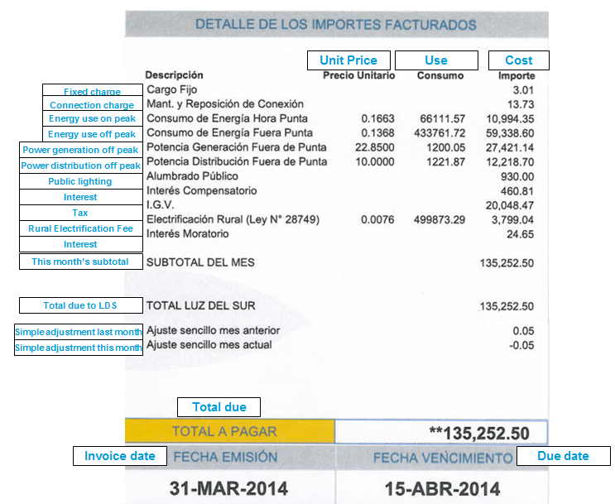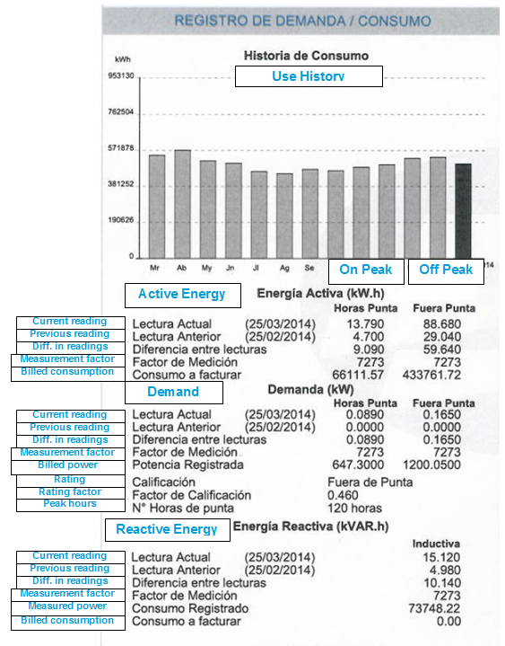

# Appendix H: Glossary of Acronyms

ASHRAE American Society of Heating, Refrigerating and Air-Conditioning

Engineers

BAS Building Automation System

Btu British Thermal Unit

CDD Cooling Degree Day

DE Design and Engineering

DHW Domestic Hot Water

DOE Department of Energy

EE Energy Efficiency

EER Energy Efficiency Ratio

ECM Energy Conservation Measure

EFCOG Energy Facility Contractors Group

EO Executive Order

ESPC Energy Savings Performance Contract

FOD Field Observed Deficiency

GPF Gallons per Flush

GPM Gallons per Minute

HDD Heating Degree Day

HVAC Heating, Ventilation and Air-Conditioning

IFMA International Facilities Management Association

IMI International Maintenance Institute

IPLV Integrated Part Load Value

kW 1 thousand Watts

kWh 1 thousand Watt Hours

MAR Meter Assessment Recommendation

MMBtu 1 million British Thermal Units

NPLV Nominal Part Load Value

O&M Operations and Maintenance

OA Outdoor Air

OBO Overseas Building Operations

OMR Operations and Maintenance Recommendation

PDCS Program Development, Coordination and Support

ppm Parts Per Million

RE Renewable Energy

REM Renewable Energy Measure

RH Relative Humidity

VAV Variable Air Volume

WCM Water Conservation Measure